Western Coastal Managers Meeting 2009
January 26-28, 2009 – San Francisco, California
Agenda and Other Information

Welcome to the 2009 Western Coastal Managers Meeting!

The meeting will be held at the Bay Conservation and Development Commission (BCDC), 50 California St., Suite 2600, 94111 (415-352-3600), in downtown San Francisco.

Check out the list of participants on page 5 and this map of all the pertinent locations:

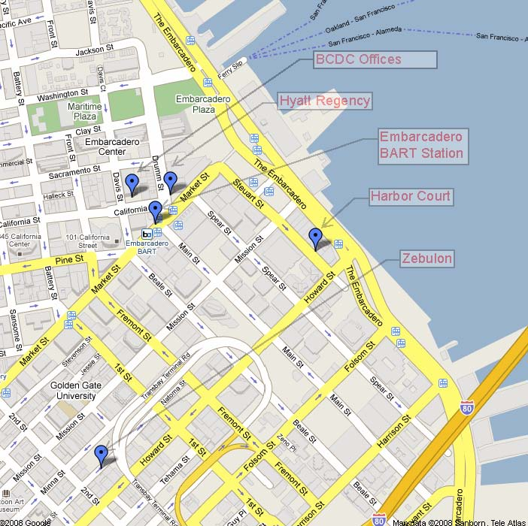

Monday, January 26, 2009

8:15 - 8:30 Coffee and Pastries

8:30 - 9:00 Welcome and Introductions
Will Travis, Bay Conservation and Development Commission

9:00 - 10:00 OCRM Update and/or Discussion
John King, Office of Ocean and Coastal Resource Management, NOAA

10:00 - 10:30 Break with Coffee

10:30- 12:00 Topic #1 Climate Change Adaptation
Climate Change Adaptation by State - Chair: Steve Goldbeck
Objective: To inform states of where other programs are on climate change and explore how best to plan for and manage climate change in the face of uncertainty and budget constraints.
State Presentations and Discussion
HI, AK, WA, OR, BCDC, CCC, SCC

12:00 - 1:00 Lunch

1:00 - 2:30 Topic #1 Climate Change Adaptation
Climate Change Research Needs - Chair: Steve Goldbeck
Objective: Agree upon management-focused research priorities for the Western Coastal states.
BCDC Climate Change Research White Paper
Steve Goldbeck, Bay Conservation and Development Commission
Facilitated Discussion

2:30 - 2:45 Break with Coffee

2:45 - 3:45 Topic #1 Climate Change Adaptation
Engaging the Public on Climate Change - Chair: Steve Goldbeck
Objective: Inform managers of some of the issues and considerations in engaging the public regarding SLR.
Engaging the Public Regarding Climate Change Adaptation
Suzanne Moser, Susanne Moser Research & Consulting

3:45 - 4:15 CPD Updates
Coastal Programs Division, NOAA

4:15 - 4:30 Wrap Up and Logistics

5:00 – 8:00 Reception at Zebulon
(Not covered by registration, located at 83 Natoma Street - 2nd & Mission)

Tuesday, January 27, 2009

8:15 - 8:30 Coffee and Pastries

8:30 - 10:00 Topic #2 Ecosystem and Place-Based Management
EBM and PBM Planning and Policy - Chair: Dan Robinson
Objective: Giving managers a better idea of how place-based planning efforts are cross-cutting, and how they are being used to help address climate change adaptation and resiliency, sea level rise, and alternative energy planning and management now and in the future.
The Evolution of Marine Spatial Planning in California: Observations and Ideas
Meg Caldwell, Center for Ocean Solutions Stanford Law School
Ecosystem-Based Management of Elkhorn Slough: Restoring processes in a time of rising sea level
Bryan Largay, Elkhorn Slough NERR
Ocean Energy in Oregon
Paul Klarin, Oregon Coastal Management Program
Integrating the Human Dimension Into Marine Planning Activities
Dr. Sarah Kruse, Ecotrust
Facilitated Discussion with Above Presenters

10:00 - 10:30 Break with Coffee

10:30 - 12:00 Topic #2 Ecosystem and Place-Based Management
EBM and PBM Tools - Chair: Christina Hoffman
Objective: Inform states about key tools and data available for place-based management within the region.
MSP as a Tool for Coastal Management
Dave Stein, Coastal Services Center
SCC’s Habitat Mapping Program and You
Rikk Kvitek, California State University Monterey Bay
Google Earth and Marine Planning
Pete Giencke, Google
Facilitated Discussion with Above Presenters

12:00 – 1:00 Lunch

1:00 - 5:00 Fieldtrip
There will be two short hikes and two stops on our tour of wetland restoration in the North Bay. We will visit Hamilton/Bel Marin Keys wetland restoration, a 2,600 acre project currently under construction, as well as Sonoma Baylands, a project finished 10 years ago. Both of these projects involved multiple partners, some of which will join us for the tour, including SCC, BCDC, and USACOE.

Wednesday, January 28, 2009

8:15 - 8:30 Coffee and Pastries

8:30 – 9:30 Topic #3 Marine Alternative Energy
Marine Alternative Energy - Chair: Paul Klarin
Objective: Prompt managers to consider a realistic perspective on the feasibility, permitting, and deployment of ocean-based alternative energy facilities, based on the limitations of the technology and infrastructure, environmental concerns and potential user conflicts.
Integrating Wave Energy into the Grid
Merko Previsic, Vision Consulting LLC
Structure for Effective Environmental Impact Analysis
Greg McMurray, Oregon Coastal Program
Interaction of Local Organizations with State and Industry
Kaety Hildenbrand, Oregon Sea Grant
Questions and Discussion

9:30 - 9:45 Break with Coffee

9:45 – 11:30 Topic #3 Marine Alternative Energy
Marine Alternative Energy - Chair: Paul Klarin
Objective: Provide state and NOAA managers with insight into the cureent siting and permitting of offshore alternative energy technologies. Determine if there is common ground for collaboration among states, and between states and federal agencies, to resolve outstanding conflicts and overlaps on jurisdictional questions.
MMS Program Evolution and Rules for Offshore Development
Maruice Hill, Minerals Management Service
FERC Regulatory Program
Jim Hastreiter, Federal Energy Regulatory Committee
Regulatory Issues and How They Affect the Development of Potential Marine Power Facilities
Therese Hampton, Pacific Ventures
Questions and Discussion for Full Panel

11:30 – 12:00 Wrap Up

12:00 – 1:30 Lunch
(On your own)

1:30 - 5:00 CZMA Performance Measurement System Workshop
Laurie Rounds, Coastal Programs Division, NOAA
- Update on OCRM Activities
- Overview of Phase 3 Performance Measures
- Coastal Hazards Measures
- Coastal Dependent Uses and Community Development Measures
- Discussion of Coastal Habitat Measure #9
- Lessons Learned and Needs
- Next Steps for Full Implementation

1 | Marnie Meyer | mmeyer@dbedt.hawaii.gov | HCMP
2 | Randy Bates | randy.bates@alaska.gov | ACMP
3 | Gina Shirey Potts | gina.shirey-potts@alaska.gov | ACMP
4 | Tom Atkinson | tom.atkinson@alaska.gov | ACMP
5 | Kim Kruse | kim.kruse@alaska.gov | ACMP
6 | Jennifer Hennessey | jenh461@ecy.wa.gov | WCMP
7 | Carrie Byron | cbyr461@ecy.wa.gov | WCMP
8 | Paul Klarin | paul.klarin@state.or.us | OCMP
9 | Jeff Weber | jeff.weber@state.or.us | OCMP
10 | Greg McMurray | mcmurrag@state.or.us | OCMP
11 | Jay Charland | jay.charland@state.or.us | OCMP
12 | Bob Bailey | bob.bailey@state.or.us | OCMP
13 | Susan Hansch | shansch@coastal.ca.gov | CCC
14 | Charles Lester | clester@coastal.ca.gov | CCC
15 | Anne McMahon | amcmahon@coastal.ca.gov | CCC
16 | Liz Fuchs | lfuchs@coastal.ca.gov | CCC
17 | Kelly Cuffe | kcuffe@coastal.ca.gov | CCC
18 | Alison Dettmer | adettmer@coastal.ca.gov | CCC
19 | Mark Delaplaine | mdelaplaine@coastal.ca.gov | CCC
20 | Al Wanger | awanger@coastal.ca.gov | CCC
21 | Tom Luster | tluster@coastal.ca.gov | CCC
22 | Jack Gregg | jgregg@coastal.ca.gov | CCC
23 | Jon Van Coops | jvancoops@coastal.ca.gov | CCC
24 | Lisa Haage | lhaage@coastal.ca.gov | CCC
25 | Robin Blanchfield | rblanchfield@coastal.ca.gov | CCC
26 | Cassidy Teufel | cteufel@coastal.ca.gov | CCC
27 | Chris Pederson | cpederson@coastal.ca.gov | CCC
28 | Mark Johnsson | mjohnsson@coastal.ca.gov | CCC
29 | Steve Goldbeck | steveg@bcdc.ca.gov | BCDC
30 | Joe LaClair | joel@bcdc.ca.gov | BCDC
31 | Tim Eichenberg | time@bcdc.ca.gov | BCDC
32 | Caitlin Sweeney | caitlins@bcdc.ca.gov | BCDC
33 | Bob Batha | bobb@bcdc.ca.gov | BCDC
34 | Adrienne Klein | adriennek@bcdc.ca.gov | BCDC
35 | Mamie Lai | mamiel@bcdc.ca.gov | BCDC
36 | Sam Schuchat | sschuchat@scc.ca.gov | SCC
37 | Nadine Hitchcock | nhitchcock@scc.ca.gov | SCC
38 | Maria Brown | maria.brown@noaa.gov | NOAA GFNMS
39 | Kelley Higgason | kelley.higgason@noaa.gov | NOAA GFNMS
40 | Daniel Howard | dan.howard@noaa.gov | NOAA CBNMS
41 | Christina Hoffman | christina.hoffman@noaa.gov | NOAA CSC
42 | Becky Pollock | rebecca.pollock@noaa.gov | NOAA CSC
43 | Becky Smyth | rebecca.smyth@noaa.gov | NOAA CSC
44 | David Stein | dave.stein@noaa.gov | NOAA CSC
66 | Dave Stein | Dave.Stein@noaa.gov | NOAA CSC
45 | Matt Gove | matt.gove@noaa.gov | NOAA CPD
46 | Kris Wall | kris.wall@noaa.gov | NOAA CPD
47 | Helen Farr | helen.farr@noaa.gov | NOAA CPD
48 | John King | john.king@noaa.gov | NOAA CPD
49 | Jen Pizza | jen.pizza@noaa.gov | NOAA OCRM
51 | Marina Psaros | mpsaros@sfsu.edu | SF Bay NERR
52 | Jaime Kooser | kooser@sfsu.edu | SF Bay NERR
65 | Bryan Largay | bryan@elkhornslough.org | Elkhorn Slough NERR
50 | Linda Duguay | duguay@usc.edu | USC Sea Grant
53 | Susan Schlosser | scschlosser@ucdavis.edu | California Sea Grant
54 | Nathalie Hamel | hamel@ecy.wa.gov | Washington Sea Grant
61 | Kaety Hildenbrand | Kaety.Hildenbrand@oregonstate.edu | Oregon Sea Grant
55 | John Hansen | john.hansen@westcoastebm.org | West Coast EBM Network
56 | Andrea Geiger | ageiger@coastalstates.org | CSO
57 | Therese Hampton | hh_solutions@comcast.net | Pacific Ventures
58 | Jim Hastreiter | James.Hastreiter@ferc.gov | FERC
59 | Greg McMurray | Gregory.Mcmurray@state.or.us | OCMP
60 | Maruice Hill | maurice.hill@mms.gov | MMS
62 | Merko Previsic | mirko@re-vision.net | Vision Consulting LLC
63 | Sarah Kruse | skruse@ecotrust.org | Ecotrust
64 | Meg Caldwell | megc@stanford.edu | Center for Ocean Solutions
67 | Rikk Kvitek | Rikk_Kvitek@csumb.edu | CSU
68 | Pete Giencke | giencke@google.com | Google
69 | Suzanne Moser | promundi@susannemoser.com | Suzanne Moser Research

